Identification of Flood-Prone Areas in Bantaeng Regency with the Hec-RAS Modeling Approach in Bantaeng Regency, Indonesia

Ilham Alimuddin¹ , Irwan²
¹Graduate Student, Department Name, Example University
Postal address of author1
Email: author1@email.address

²Lecturer, Urban and Regional Planning Department, Hasanuddin University,
Faculty of Engineering Gowa Campus, Jl. Malino no 8F
Email: irwan.pwk@yahoo.com

KEY WORDS: Flood, Hec-RAS, GIS, Bantaeng Regency, Flood Simulation

ABSTRACT: Flood is one of the most common natural disasters in Indonesia. This condition is caused by many factors, including climate change, environmental damage, especially in the upstream area and a decrease in environmental quality in urban areas. Bantaeng is one of the districts on the south coast of South Sulawesi Province and is a district that is prone to flooding which occurs almost every year. The flood modeling approach using HecRAS which will be encoded with spatial pattern data in Bantaeng Regency provides its own value in the form of creating an approach that is integrated with existing development policies in Bantaeng Regency. Flood simulation with is obtained by using discharge data obtained from SWAT results in broad watershed areas that have high and very high flood hazard classes. The results of the HEC-RAS are modeling the potential distribution of flood areas based on GIS. The simulation results are then superimposed with administrative boundaries and produce a detailed area for each watershed. Based on the flood event model in several watersheds in Bantaeng Regency, it can be concluded that each watershed has different characteristics in terms of flood events, so it is necessary to handle flood events based on the characteristics of each existing watershed.The highest flood-affected area is shown in the Lumpangan Watershed with an area of 1,262.36 ha with affected sub-districts namely Bantaeng District, Eremerasa District, Gantarang Keke District, Pajukukang District and Tompo Bulu District with an area of 166.07 ha or 22.11% of the total area affected impact. Specifically for urban areas, Bantaeng District has a flood potential area of 298.72 ha with the influence of flood potential from the Biangloe, Binanga, Binanga Lamalakka, Lumpangan and Onto watersheds..

Introduction
The disaster that occurs has consequences that affect humans and/or their environment. Vulnerability to disasters can be caused by a lack of proper disaster management, environmental impacts, or humans themselves. The losses incurred depend on the community's resilience capacity to disasters.

Indonesia is one of the developing countries vulnerable to various natural disasters, especially floods. Floods are a common occurrence in Indonesia, particularly during the rainy season. This leads to very adverse impacts on human lives, the economy, and the environment.

Floods are caused by two categories: natural floods and floods due to human activities. Natural floods are influenced by rainfall patterns, physiography, erosion and sedimentation, river capacity, drainage capacity, and tidal influences. On the other hand, floods due to human activities are caused by human actions that result in environmental changes, such as changes in the conditions of Watersheds (DAS), residential areas near riverbanks, damage to land drainage, flood control structure damage, deforestation (natural vegetation), and inadequate/inappropriate flood control system planning.

In 2020, due to high rainfall in the southern part of South Sulawesi Province, floods occurred in several districts of South Sulawesi, including Bantaeng. One of the causes of the floods in Bantaeng District was the overflowing of the Calendu River, resulting in seven sub-districts being affected by the flood. In addition to the overflowing of the Calendu River, the flood was exacerbated by the breach of the Balang Sikuyu Check Dam due to its inability to contain the high water discharge. Urban drainage problems and the presence of numerous rivers in the urban areas of Bantaeng District also contributed to the severity of the urban flooding.

The topographical conditions of the urban areas in Bantaeng District, which extend along the coast, make these areas highly vulnerable to flooding. This vulnerability is further increased by the numerous rivers that traverse the coastal areas from Bissapu Sub-District, Bantaeng Sub-District, Pa'jukukang Sub-District to the Marina beach bordering Bantaeng District. The presence of many rivers implies an increased burden of drainage water discharge when heavy rainfall coincides with the highest tide of the sea. It is the characteristics and conditions of Bantaeng District that make this area highly prone to flooding, necessitating a comprehensive study in terms of territorial aspects, infrastructure, and disaster mitigation to reduce the impact of future flood events in Bantaeng District.

Research objectives
Spatial-based data relating to archaeological resource management in the Maros and Pangkep Karst Prehistoric Cave Areas is abundant. By utilizing existing data, in this research an effort will be made to embrace and combine various kinds of data that are available so that they can be packaged as a information systems, more details The objectives to be achieved in this research are as follows:
1. Building a database of potential prehistoric caves in the Leang Leang Sub Area and the Bulu Sipong Sub Area which can be updated at any time;
2. Formulate a form of information system that can be used as material for data analysis related to threats, decision making regarding conservation policies, as well as further research.

Flood events in Bantaeng Regency
Flood events are identified using the Normalized Difference Sigma Index (NDSI) approach. This formula uses data before the flood (master) and after the flood (slave) at different times with band math tools and then enters the NDSI formula which in this study is (before the flood - after the flood)/(before the flood + after the flood).

The NDSI approach uses Sentinel 1A SAR data by identifying minimum pixel values using pixel info tools assisted by vector tools to retrieve minimum flood pixel values. This result only shows the distribution of floods in raster data format which will then be processed into vector data. The results of the process can be seen by visualizing the distribution of floods that have been in the coregistration process

In the NDSI results, the data cannot be used further to analyze flood vulnerability in this research because it is still in raster format. Then the data is converted from raster to vector to obtain other spatial information such as the extent of the flood. After the next vectorization process, to obtain ideal flood results, the vector results are eliminated for each year of flood event data with a flood area of <2 ha because this value is considered suitable in the model simulation. After the elimination process, all flood data is combined to form a flood event map in Bantaeng Regency.

This result is a form of visualization of flood events based on the time of flood events used (five years). Flood incidents spread across several sub-districts in Bantaeng Regency. The extent of flood events in each sub-district can be seen in Table 1 and spatially depicted in Figure 1.
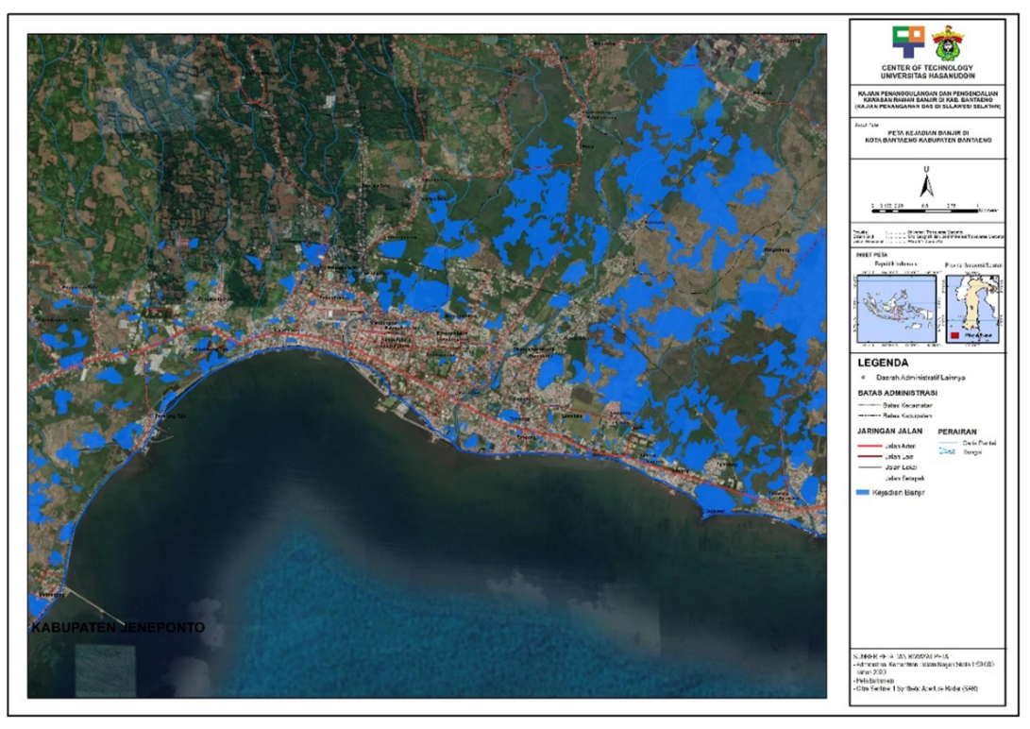

Figure 1 Flood Extent in Bantaeng Regency 2017-2021

Table 1 Flood Coverage Area in Kabupaten Bantaeng Year 2017-2021
Kecamatan | Luas Kecamatan |  | Luas Banjir
 | ha | (%) | ha | (%)
Bantaeng | 2.973,03 | 7,44 | 352,63 | 0,00
Bissappu | 3.909,82 | 9,78 | 172,26 | 10,34
Eremerasa | 4.518,09 | 11,31 | 182,91 | 10,98
Gantarang Keke | 5.667,66 | 14,18 | 382,60 | 22,96
Pajukukang | 5.003,83 | 12,52 | 575,88 | 34,56
Sinoa | 3.948,75 | 9,88 | 0,00 | 0,00
Tompo Bulu | 7.476,07 | 18,71 | 0,00 | 0,00
Uluere | 6.464,92 | 16,18 | 0,00 | 0,00
TOTAL | 39.962,17 | 100,00 | 1.666,29 | 100,00
Source: GIS Analysis

Flood driven factors
The level of flood vulnerability is analyzed using the frequency ratio method by dividing the rate of flood events by the area ratio for each causal factor. The flood factors used in this analysis are land cover, soil texture, rainfall, curvature, slope class, height, lithology and river distance.

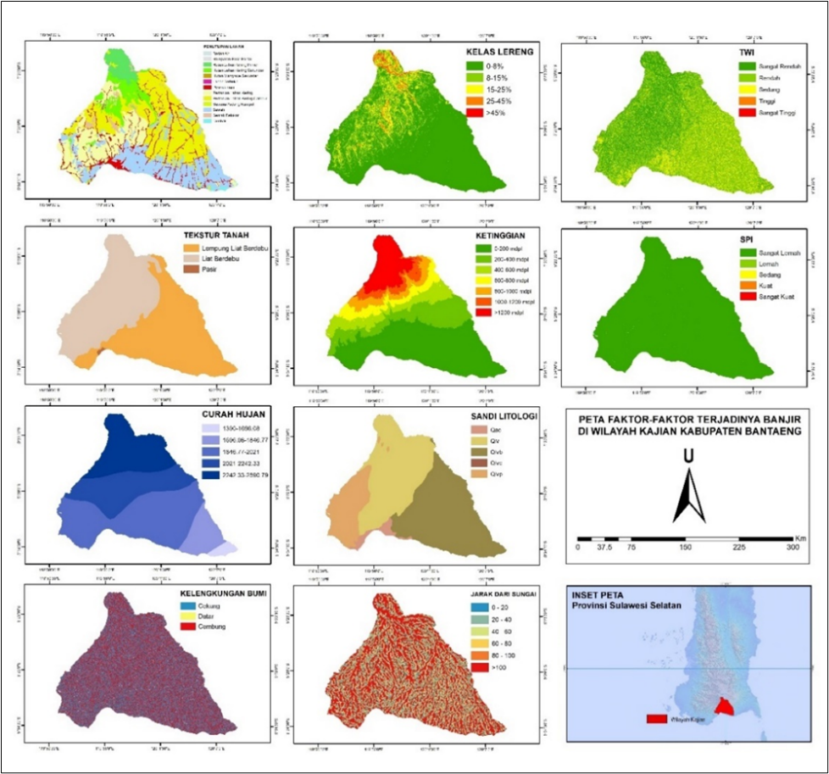

Figure 2. Factorial Class of Flood (GIS Analysis, 2022)

A ratio value of greater than 1.0 indicates that the relationship between flood events and the causal factors is higher, while a ratio value of less than 1.0 indicates that the relationship between flood events and the causal factors is low. Results of calculating flood probability values with flood-causing factors.

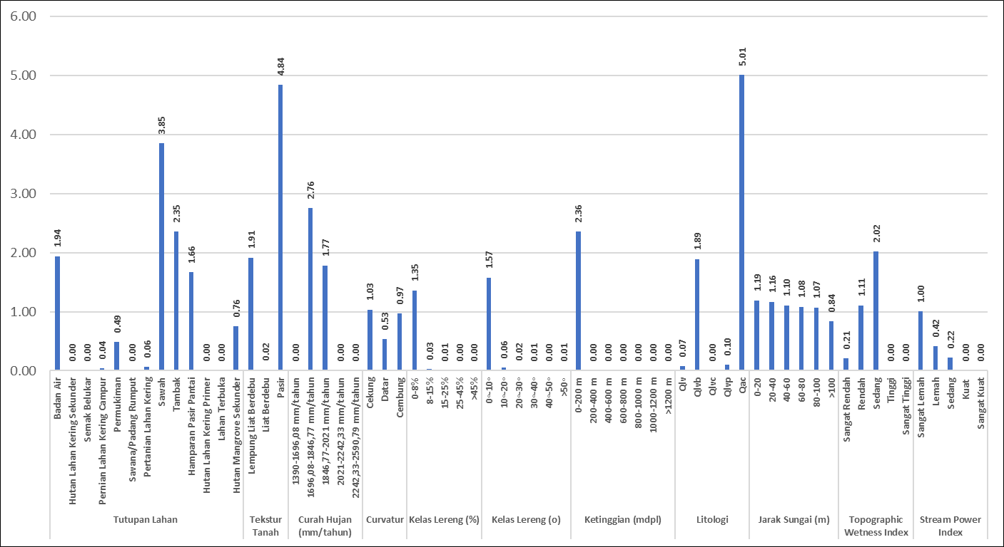

Figure 3. Frequency ratio value of factors causing flooding (results of data analysis)

Flood Vulnerability Level
The level of flood vulnerability is obtained from the flood vulnerability index. Obtaining a flood susceptibility index (FSI) is the result of adding up all rasters of flood-causing factors with their frequency values. This FSI value is classified based on natural breaks (Jenks), or a model for determining data points based on data groupings and patterns.

Table 2. Flood Vulnerability Class
Class | Reclassify Index value | Flood Vulnerability Class | Pixel Number | % Pixel
1 | 2,47-5,12 | Very Low | 1.144.258 | 25.48
2 | 5,12-8,24 | Low | 888.483 | 19.79
3 | 8,24-12,02 | Medium | 780.976 | 17.39
4 | 12,02-15,96 | High | 817.083 | 18.20
5 | 15,96-24,42 | Very High | 859.416 | 19.14
Source: GIS Analysis

The level of flood vulnerability is divided into five classes including very low, low, medium, high and very high which are spatially depicted in Figure 4.16. The level of flood vulnerability is very high and highly concentrated in the downstream areas of the watershed with sub-districts including Pajjukukang, Gantarang Keke, Bantaeng, Bisappu. Meanwhile, the very low, low and medium classes cover the upstream watershed area with the sub-districts of Sinoa, Eremerasa, Tompobulu and Uluere.

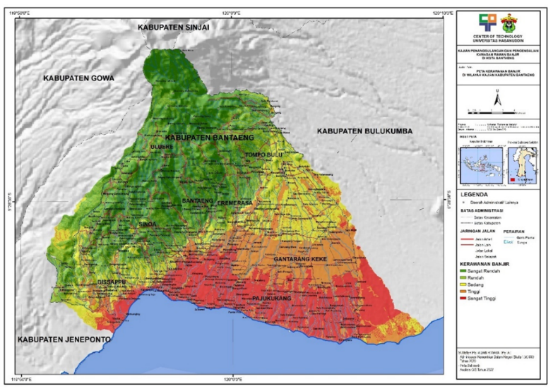

Figure 4. Flood Vulnerability Map (GIS Analysis Results, 2022)

Result and conclusion

The HEC-RAS program is a program package from ASCE (American Society of Civil Engineers). HEC-RAS is designed to simulate one-dimensional flow. This software provides convenience with its graphic display. In this HEC-RAS software, the condition of river water can be traced under the influence of hydrology and hydraulics, as well as further river management according to needs (Wigati, 2016). Flood simulations with the HEC-RAS model are obtained using discharge data obtained from SWAT results in watershed areas that have extensive high and very high flood vulnerability classes. The results of HEC-RAS are modeled on the potential distribution of flood areas based on GIS using ArcGIS software, then superimposed with administrative boundaries and produce an area area which is presented in detail.

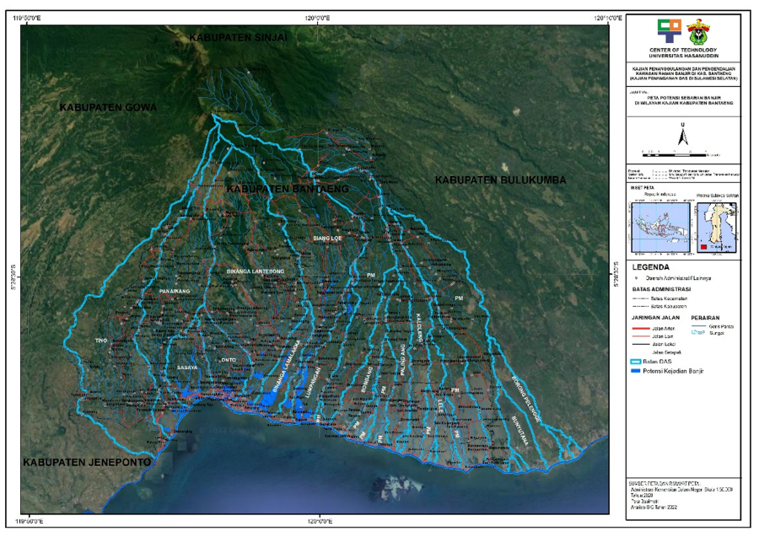

Figure 5. Map of Potential Flood Distribution in Bantaeng Regency using HEC-RAS

Watershed Flood Potential Model
3.1.1. Biang Loe Wtaershed Food Model
Based on the results of flood potential modeling. Flood events in the Biangloe watershed tend to accumulate at one end point with little runoff in the upstream area. From this condition, flood control in the Biangloe watershed is focused on buildings and downstream flood control systems in the form of river improvement.

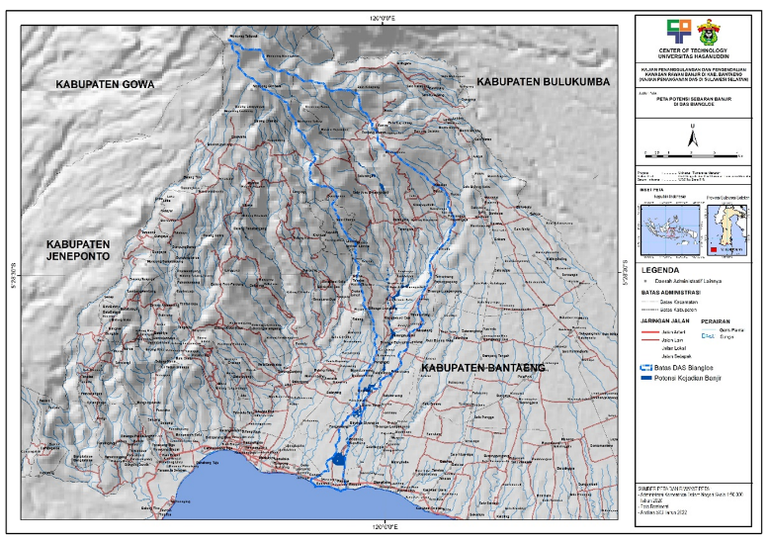

Figure 6. Biang Loe Wtaershed Food Model
3.1.2. Model banjir das binanga lamalaka

The Binanga Lamalaka watershed is a watershed with a fairly large potential flood area. Another characteristic of potential flooding in this watershed is that water overflows have started to occur in areas upstream.

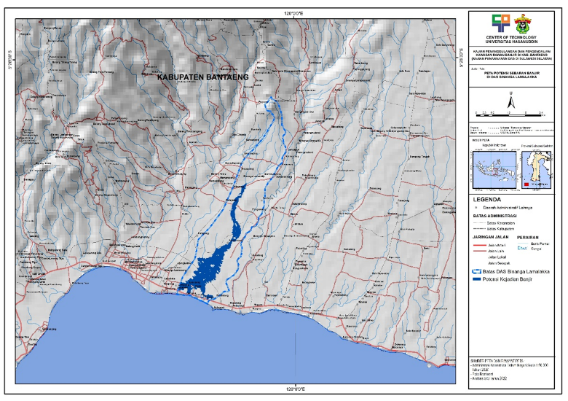

Figure 7. Lamalaka Watershed Flood Model

3.1.3. Binanga Lantebong Watershed Model

The distribution of potential flood areas in the Binanga Lantebong Watershed is in the form of certain location points and are not close to each other and are mostly located in downstream areas. The characteristics of potential flooding with a spreading pattern in the Binanga Latebong River Basin are influenced by topography.
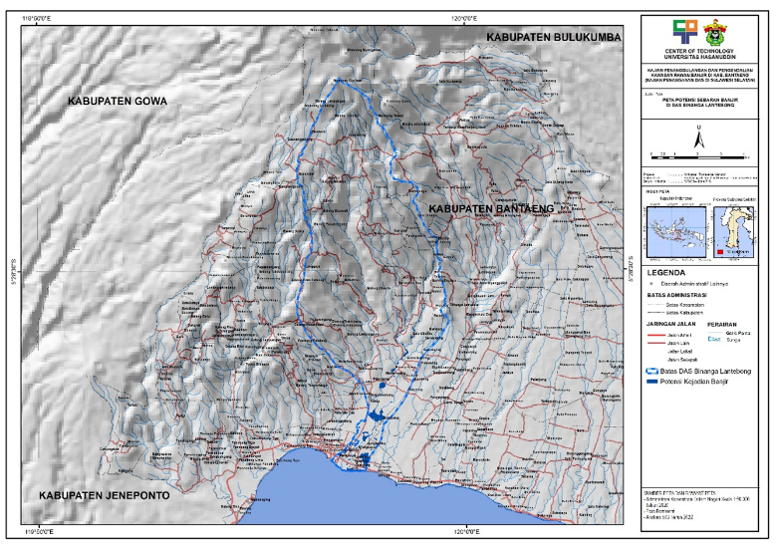

Figure 8 Lantebong Watershed Model

3.1.4. Lumpangan Watershed Model

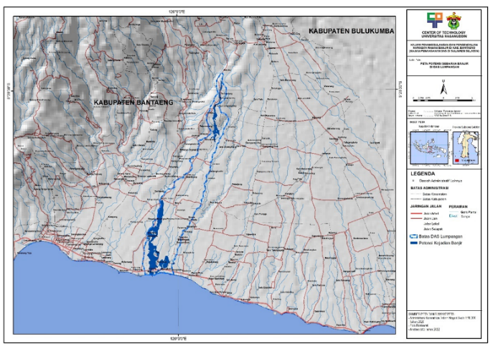
The distribution of potential flood areas in the Binanga Lantebong Watershed is in the form of certain location points and are not close to each other and are mostly located in downstream areas. Characteristics of potential floods with a spreading pattern.

Figure 9. Lumpangan Watershed Model
3.1.5. Onto Watershed Model

The characteristic of potential flooding in the Onto River is flooding in urban areas.

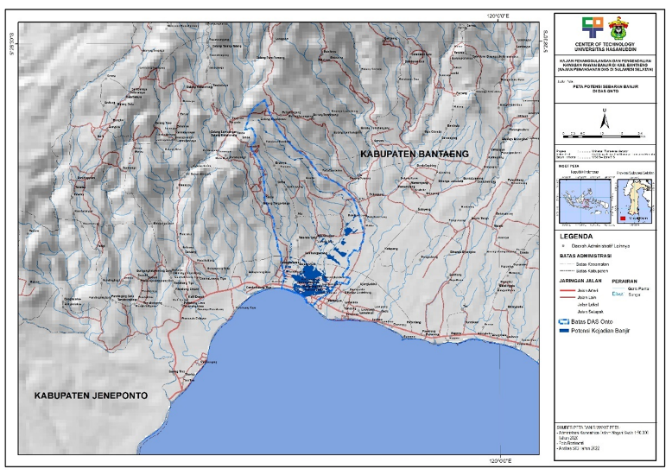

Figure 10. Onto Watershed Model.

Acknowledgements (optional)
We acknowledge the support received from Faculty of Engineering Hasanuddin University.

References and/or Bibliography
References from Journals:

Aung Pyae Phyo, Helmut Yabar, Delmaria Richards, Managing dam breach and flood inundation by HEC-RAS modeling and GIS mapping for disaster risk management, Case Studies in Chemical and Environmental Engineering,2023.

Hunegnaw Desalegn, Arega Mulu, Mapping flood inundation areas using GIS and HEC-RAS model at Fetam River, Upper Abbay Basin, Ethiopia, Scientific African, Volume 12, 2021.

C. Ben Khalfallah, S. Saidi, Spatiotemporal floodplain mapping and prediction using HEC-RAS - GIS tools: Case of the Mejerda river, Tunisia, Journal of African Earth Sciences, Volume 142, 2018.

